Tejash Shukla 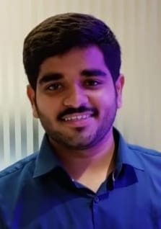
121/4 site no 1 Kidwai Nagar
Kanpur, U.P
tejashshukla6@gmail.com
6387969277

Summary
I am looking for a internship that makes the best use of my skills and allows me to develop them. I have developed good planning and organizational skills and am confident working independently or as part of a team. I am a good timekeeper, always ready to learn new skills. I am friendly, helpful I do my work with perseverance and dedication, I always get ready to learn new skills. I am friendly, helpful, a family man with responsibilities, very reliable and dependable..

Qualification
- MCA (Bachelors of Computer Application) From MMMUT ( Appearing)
- BCA (Bachelors of Computer Application) From CSJMU in 2023
- Intermediate (Commerce Stream)From ICSE Board In 2020
- High School(Commerce Stream)From ICSE Board In 2018

Professional Essence
Expertising: C/C++, Python,Java
Expertise: C, C++,Python
Personality: Quick learner, Diligent and authentic spirit, communication skills
Value Addition
- Pursuing Web Developing program from Udemy
- Worked On Jarvis Assistant Project

Technical Skills
- C
- C++
- Python
- Microsoft office
Experience
Python Jarvis Project
Personal Profile
Date of Birth: 2/11/2002
Gender: Male
Nationality: Indian
Language: Hindi, English
Hobbies: making creative Programms,
learning new technical skills
Exploring technical things

